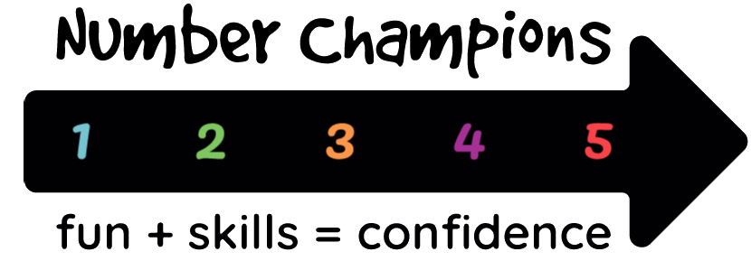 | Gift Aid Declaration

If you are a UK taxpayer, by making this Gift Aid declaration you can boost your donation to Number Champions by 25p for every £1 you donate at no cost to yourself. We will receive the extra 25p from HM Revenue and Customs. If you are a higher rate taxpayer, you will be able to reclaim tax separately from HMRC for your donation.

In order to Gift Aid your donation please return this form to mail@numberchampions.org.uk from your personal email account. If you instead return it in hard copy, please sign in the signature box. (Or you can sign and take a JPG or PDF copy and return that by email.)

You need to complete the details in the box below: title, first name or initial, surname, full address and postcode, and date. HMRC requires us to collect this data.

I want to Gift Aid any donations I make in the future or have made in the past four years to Number Champions.

I am a UK taxpayer and understand that if I pay less Income Tax and/or Capital Gains Tax than the amount of Gift Aid claimed on all my donations in that tax year it is my responsibility to pay any difference.

My details are
Title
First name or initial
Surname
Full Home address
Postcode
Date

Signature – not needed if you return this form electronically from your personal email

Please notify Number Champions if you:
• want to cancel this declaration
• change your name or home address
• no longer pay sufficient tax on your income and/or capital gains.

If you pay Income Tax at the higher or additional rate and want to receive the additional tax relief due to you, you must include your Gift Aid donations on your Self-Assessment tax return or ask HMRC to adjust your tax code.

Data protection statement
Number Champions has to keep records of your details for six years from your last donation in order to satisfy HMRC’s requirements. We will share the information you give with HMRC as required, but we will not share it with any other organisation, and we will not use it internally except to process Gift Aid. We will delete your information when the six years is completed.

