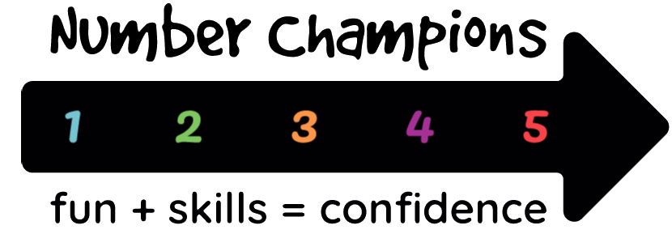 | Evaluation of impact by the teacher

Teacher: please complete a copy of this form for each child and provide all forms to your school administrator by the end of June. (If a child leaves or otherwise is removed from the scheme early, please complete and forward the form at that time.)

School administrator: please collate all teachers’ forms and send them to the Number Champions administrator or email scanned versions to mail@numberchampions.org.uk by 8 July.

(Please give the child’s first name only, adding, if necessary, the minimum leading letters of the surname to identify the child uniquely on the class roll.)

School Year | 2021-22
Date
School
Teacher
Class
Child
Volunteer

Question 1. How has the child’s confidence in maths changed since taking part in Number Champions?
Very much better |  | Please put X in one option
Noticeably better
A little better
The same
Worse

Question 2. How has the gap in mathematical attainment between the child and the rest of the class changed since taking part in Number Champions?
Very much reduced |  | Please put X in one option
Noticeably reduced
A little reduced
The same
Worse

Please give below any feedback which you feel would be useful, both as regards further comment on the evaluations above and as regards the scheme as a whole.

