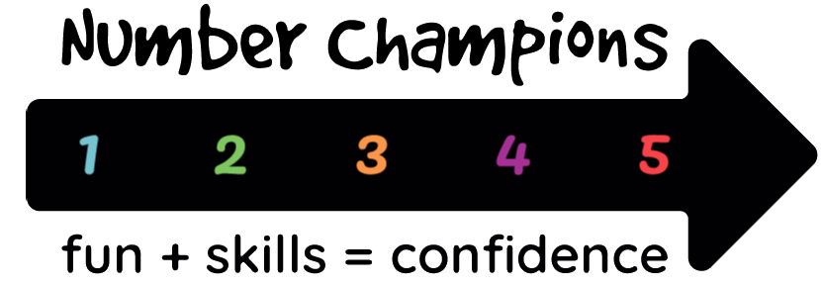 | Teacher’s selection of child

A copy to be completed by the teacher for each child selected for the scheme.

The child’s name should be the first name only plus, if necessary, the minimum leading letters of the surname to identify the child uniquely on the class roll. Birth ‘quarter’ and ‘school year of birth’ are requested to allow analysis of age effects while limiting identification of individual children. Gender will also be used to allow statistical analysis in future.

School Year 2021-22

School
Teacher
Class year |  | Eg 1, 2, 3 etc
Class name
Child’s name:
Gender |  | M or F (or X if reasons not to assign)
Quarter of birth |  | Sep = Sep/Oct/Nov Dec =Dec/Jan/Feb  Mar = Mar/Apr/May Jun = Jun/Jul/Aug
Wrong school year? |  | Blank if child is in the right year, otherwise “Young” or “Old”

- In what way does the child’s ability in maths fall behind what would be normal at his or her age? Are there specific points within the curriculum where the child has difficulties?

- Are there areas of improvement which you would like the volunteer to focus on? What would be realistic targets? If possible reference this to specific items in the curriculum.

- Is there any specific feedback you would like from the volunteer?

- Is there any information about the child which it would help the volunteer to know? (It may be useful to supplement this verbally with the volunteer.) This should include any conditions - such as serious allergic reactions - which can result in medical emergencies.

